Independent Reading at Sunbury College
Every Year 7, 8 and 9 student participates in weekly Independent reading sessions
Independent reading is a designated time where students:
- Read continuously
- Keep their your own records
- Reflect on their reading
- Confer with their English teacher about reading
- Think about and write responses to their reading
- Practise decoding and comprehension strategies
- Practise and reinforce vocabulary (new, known and high-frequency words)
- Practise reading for fluency (rate and prosody)
- Determine the author’s purpose
- Think critically about texts
- Enjoy reading for extended periods of time

Rationale for weekly sessions:

- Reading leads to success
- Reading enhances our knowledge
- Reading helps us to learn about the world
- Reading enriches our creativity
- Reading expands our vocabulary
- Reading increases our concentration and focus

- Reading improves our communication skills
- Reading will help you get a good job
- There will always be something you need to read
- The only way to get better is to practise

Independent reading promotes active problem solving and higher-order cognitive processes. It is these processes which equip each student to read increasingly more complex texts over time; resulting in better reading comprehension, writing style, vocabulary, spelling and grammatical development.

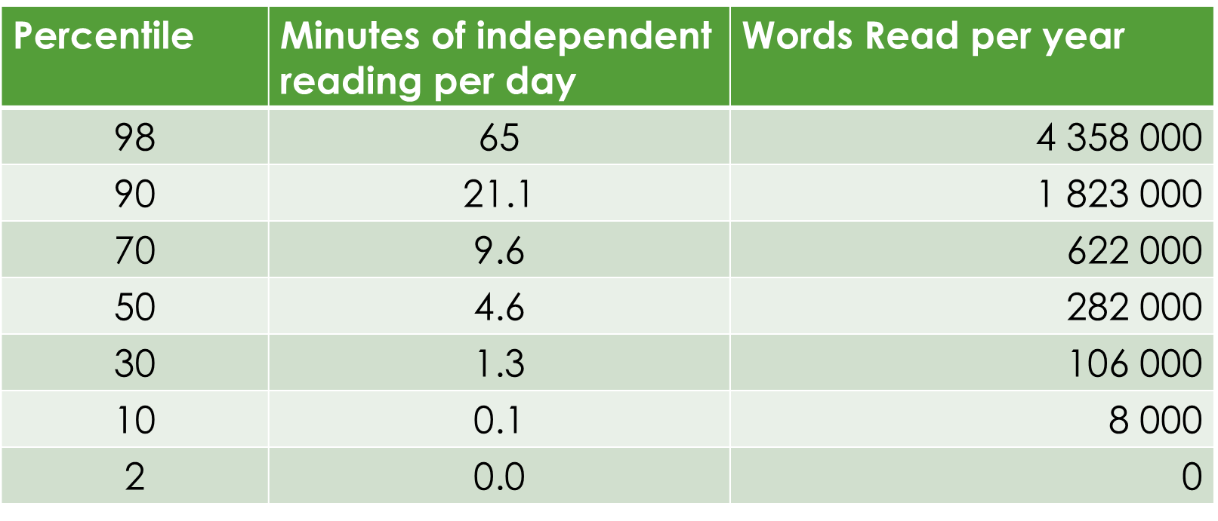

Adapted from Anderson R.C. Wilson, P.T & Fielding, L.G (1988) Growth in reading and how children spend their time outside, Reading Research Quarterly “Creating Lifelong Readers through Independent Reading” Moss & Terrell page 15

