Key Reading Strategies
Monitor
To become aware of your thinking as you read and monitor your understanding and keep track of meaning

Your child should:
- Monitor their understanding and keep track of meaning
- Listen to the voice in their head to make sense of the text.
- Notice when they stray from thinking about the text
- Notice when meaning breaks down

Activate and Connect
Making meaningful connections with the text and your own life.

Your child should:
- Access their prior knowledge and experiences.
- Use 3 ways to make connections
    - Text to self - Comparing and evaluating background experiences and images with information and descriptions presented
    - Text to text - Comparing and analysing characters, plots, themes, information, purposes, descriptions, writing styles and versions of texts.
    - Text to world - Comparing and considering text information with knowledge of the world.

Question
Good readers generate questions before, during and after reading.
Your child should:
- Use what, when, where and who type questions
- Use how and why type questions for deeper understanding
- Once a question is formed, aim to determine their answer by continuing to read.
Predict
An educated guess about what happens next.
Your child should:
- Activate prior knowledge
- Think on both a literal and inferential levels
- Supplement or modify your knowledge
- Make connections

Visualise
Recreating an image in your head of what you’re reading.
Your child should:
- Use all 6 senses (6 being emotions)
- Imagine the taste, sight, touch, emotions, sounds, sight, smells that take place.
- Recall prior knowledge
- Connect and compare to own experiences.

Infer
Think about what the writer means but has not stated.
Your child should:
- Use the information that is in the text
- Use prior knowledge
- Pause and reflect on what they are reading

Summarise
Representing in a few sentences and in your own words the most important ideas or events.
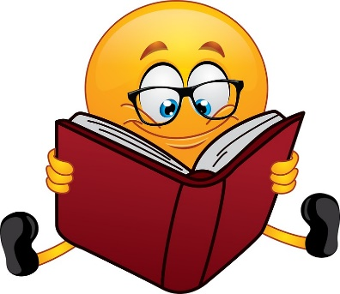
Your child should:
- Identify important information
- Distinguish between topic and main idea.
- Identify and generalise important information and ideas.
- Sequence events and ideas
- Identify genre and text structure
- Paraphrase
- Question

Synthesise
Combining prior knowledge with new information to create new thoughts, ideas, opinions or perspectives.
Your child should:
- Summarise information and determine the most important details
- Carefully consider the purpose and meaning of the text
- Think beyond the text
- Answer the ‘how’ and ‘why’ questions themselves.

