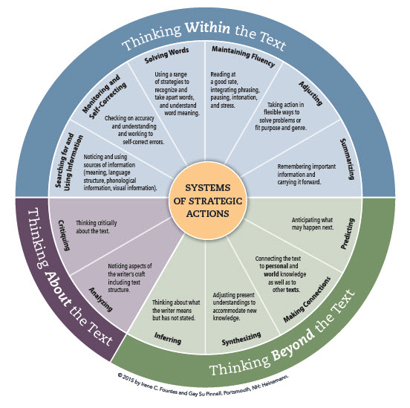

‘*The common thread is that most children acquire a fully developed literacy processing system that grows and expands over the years. It is helpful to have in mind a clear picture of what effective readers do as they build their systems so we can think about what all readers need to be able to do.’*

*(Fountas and Pinnell 2009)*